THE LANGUAGE OF FOOD

Dan Jurafsky

MONDAY, JULY 11, 2011

Ice Cream
As for the names of the flavors, mostly they are just the names of the ingredients ("chocolate", "strawberry", "orange blossom", and so on). We commonly assume that such flavor names are purely descriptive, and that factors like the sounds of the names should have no bearing on how the ice cream tastes. To paraphrase Shakespeare's Romeo and Juliet:
What's in a name? that which we call a rose sherbet
By any other name would smell as sweet;
Juliet was roughly correct; the sounds (or "phones") that make up a word don't generally tell you what the word means. By 500 BC Plato (in the Cratylus) and the Chinese linguist Xunzi of the Chinese Warring States period had figured out that the relationship between sound and meaning is usually arbitrary. A moment's thought makes it clear why this must be true: different languages have totally different sounds for the same concept, and languages only have around fifty or so phones, and obviously have a lot more ideas to express than fifty.
But it turns out that research over the last century has shown that Shakespeare was wrong; sometimes the sounds of a name do influence how people perceive ice cream. The phenomenon of sounds carrying meaning is called "sound symbolism". 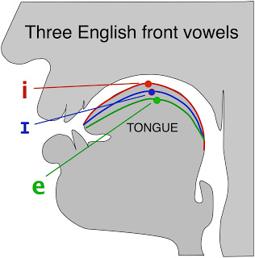Sound symbolism has been most deeply studied with vowels, and in particular the difference between two classes of vowels, front vowels and back vowels, which are named depending on the position of the tongue. The vowels I (the vowel in the words cheese or bean) and ɪ (the phonetics symbol is a small capital I, pronounced as inmint or slim) are front vowels because they are made by holding the tongue high up in the front part of the mouth. The picture to the left shows a very schematic cutaway of the head, showing the lips and teeth on the left, and the tongue high up toward the front of the mouth.
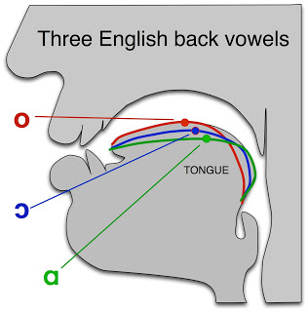By contrast, the vowel ɑ (as in large, pod, or on) is a low back vowel; this sound is made by holding the tongue lower in the back part of the mouth; other back vowels are o (as in cold) and ɔ (as in the word pour or my mother's New York pronunciation of ought). The picture to the right shows a very schematic tongue position for these vowels; lower in general, and more toward the back of the throat.
A number of studies over the last 100 years or so have shown that front vowels in many languages tend to be used in words that refer to small, thin, light things, and back vowels in words that refer to big, fat, heavy things. It's not always true, but it's a tendency that you can see in any of the stressed vowels in words like little, teeny or itsy-bitsy (all front vowels) versus humongous or gargantuan (back vowels). Or the ivowel in Spanish chico (front vowel meaning small) versus gordo (back vowel meaning fat). Or French petit (front vowel) versus grand (back vowel).
In one marketing study, for example, Richard Klink created pairs of made-up product brand names that were identical except for having front vowels or back vowels: nidax (front vowel) verus nodax (back vowel), or detal (front vowel) versus dutal (back vowel). For a number of hypothetical products, he asked people which seemed bigger or smaller, or heavier or lighter, with questions like:
Which brand of laptop seems bigger; Detal or Dutal?
Which brand of vacuum cleaner seems heavier, Keffi or Kuffi?
Which brand of ketchup seems thicker, Nellen or Nullen?
Which brand of beer seems darker, Esab or Usab?
In each case, the participants in the study tended to choose the product named by back vowels (dutal, nodax) as the larger, heavier, thicker, darker product. Similar studies have been conducted in various other languages.
The fact that consumers think of brand names with back vowels as heavy, thick, richer products suggests that they might prefer to name ice cream with back vowels, since ice cream is a product whose whole purpose is to be heavy and rich.
Indeed, it turns out that people seem to (at least mildly) prefer ice creams that are named with back vowels. In a study in the Journal of Consumer Research Eric Yorkston and Geeta Menon had participants read a press release describing a new ice cream about to be released. Half the participants read a version where the ice cream was called "Frish" (front vowel) and the other half read a version where it was called "Frosh" (back vowel), but the press release was otherwise identical. Asked their opinions of this (still hypothetical) ice cream, the "Frosh" people rated it as smoother, creamier, and richer than the "Frish" people, and were more likely to say they would buy it. The participants were even more influenced by the vowels if they were simultanously distracted by performing some other task, suggesting that their response to the vowels was automatic, at a non-conscious level.
If people subconsciously think of ice cream names with back vowels as richer and creamier, it suggests that actual ice cream brands or flavors might also use back vowels. So I ran what Mark Liberman calls aBreakfast Experiment™; a quick experiment using some easy-to-access language data. My hypothesis was that we would see more back vowels in names of actual ice cream brands or flavors. Furthermore, if front vowels indeed indicate thin, small, light , we should expect more front vowels in foods that supposed to be thin and light, like crackers.
To test the hypothesis I downloaded two lists of food names from the web. One was a list of 81 ice cream flavors that I constructed by including every flavor sold by either Haagen Dazs or Ben & Jerry's. The second was a list of 592 cracker brands from a dieting website. For each list, I counted the total number of 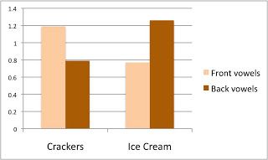front vowels (i, ɪ, ɛ,e,æ) and the total number of back vowels (details of the study are here). The result, shown in the table to the right, is that ice creams names indeed have more back vowels and cracker names have more front vowels.
Here are some examples of stressed back vowels in ice cream names:
Rocky Road, Jamoca Almond Fudge, Chocolate, Caramel, Cookie Dough, Coconut
And here are samples of the many cracker names with front vowels; note the extraordinary number of ɪ vowels:
Cheese Nips, Cheez It, Wheat Thins, Pretzel thins, Ritz, Krispy, Triscuit, Thin Crisps, Cheese Crisps, Chicken in a Biskit, Snack sticks, Toasted chips, Ritz bits

